**Enum Dropdown with Search**

**Description**

The "Enum Dropdown with Search" widget is a user interface component known as a "React Select" widget. This widget offers users the capability to perform searches within the dropdown menu, allowing for efficient navigation and selection of options. Additionally, it includes a convenient feature enabling users to clear the data with a single button click, enhancing the overall user experience in managing and interacting with the dropdown options.

**Typical Usage Scenario**

Suppose your application involves the use of an Enumeration data type, and you find the need for a search feature within the dropdown menu. In that case, this widget becomes a valuable tool. It allows you to incorporate a search functionality seamlessly, enhancing the user experience when dealing with the dropdown options associated with the Enumeration data type in your application.

**PreRequisites**

NA

**Features and Limitations**

1. Search- The "Search" feature within this context refers to the functionality that enables users to conduct searches directly within the dropdown menu. This feature is designed to enhance user navigation and ease of selection by allowing them to input specific keywords or terms, facilitating the quick identification of desired options within the available dropdown choices. It streamlines the process of finding and selecting items, contributing to a more efficient and user-friendly experience.
2. Clear- The "Clear" feature within this context offers users the convenience of clearing data with a single click. This functionality is designed to streamline the user experience by providing an efficient way to remove or reset selected data within the widget. Instead of requiring multiple steps or interactions, users can simply click the "Clear" button, resulting in the prompt removal of any previously selected data. This feature contributes to a more user-friendly and intuitive interface, enhancing the overall usability of the widget in managing and manipulating data.
3. This simplicity in implementation enhances user accessibility, making it easy for individuals to adopt and integrate the functionality into their system or application without the complexities associated with configuration requirements.

**Dependencies**

1. Require Mendix 9.1.0 or above.

**Installation**

1. Download the widget from marketplace.
2. From Add-ons tab drag and drop “Enum Dropdown with Search” widget on your Mendix page
3. Configure the following properties in the Widget-
   1. **Attribute-** Select the enumeration attribute linked to the Enum Dropdown widget, storing user input. This ensures a dynamic connection between the chosen attribute and the widget, facilitating the storage of user-selected values within the application data model.

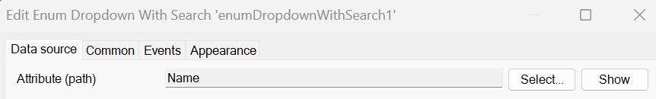

* 1. **Label-** If you wish to display an optional field, choose "Yes" and enter the corresponding text. This entered text will be presented as the label for the optional field.



* 1. **Editability-** Utilize this feature to display editable conditions for the widget, indicating whether it is editable, readable, or specifying under which circumstances it becomes editable. This functionality provides a clear representation of the widget's status, allowing users to understand and interact with it based on the defined conditions.



* 1. **Visibility-** Specify the visibility settings for the widget, indicating whether it should be visible in all scenarios or if there are specific conditions determining its display. This functionality allows for precise control over when the widget is shown, ensuring a tailored and contextually relevant user interface based on defined visibility conditions.

* 1. **Events-** This feature dictates the action to be taken upon a dropdown value change. It allows you to specify the behavior triggered when the dropdown selection is modified, enabling you to define and execute actions in response to dynamic user input. This capability enhances the interactive nature of the application, tailoring responses based on dropdown value changes.

**Configuration: NA**

**Category: Module**

**Subcategory: All**

**Visibility: Public Marketplace**

**Studio Pro Version: 9.1.0**